Contents

1. Introduction 2

Background and Motivation for the Project 2

Project Objectives 3

4. Model Training 6

5. Conclusions: 9

References 10

# List of Figures

Figure 1 7

Figure 2 7

Figure 3 8

Figure 4 8

Figure 5 9

Figure 6 9

Figure 7 10

Figure 8 10

Figure 9 11

Figure 10 11

Figure 11 12

# 1. Introduction

Anomaly detection in network traffic is a critical aspect of cybersecurity, enabling the identification of suspicious patterns indicative of malicious activities, a task for which machine learning is well-suited. Utilizing the NSL-KDD dataset, this project seeks to extract and select features that are pertinent to anomaly detection, employing techniques such as Principal Component Analysis (PCA) and Information Gain.

By leveraging algorithms such as Isolation Forest, One-Class Support Vector Machine (SVM), and K-Means Clustering, in conjunction with Python libraries such as scikit-learn and pandas, we aim to improve the accuracy and efficiency of anomaly detection.

## Background and Motivation for the Project

In today's interconnected world, the security of network infrastructures is of utmost importance. Anomaly detection in network traffic is vital for identifying potentially malicious activities that deviate from normal behavior patterns. Traditional rule-based approaches have limitations in detecting complex anomalies, highlighting the need for advanced techniques like machine learning. Machine learning provides a promising approach to enhance anomaly detection accuracy by identifying subtle and complex abnormalities that may escape traditional methods. By leveraging machine learning algorithms, we can analyze vast amounts of network traffic data and identify patterns indicative of security threats. The primary goal of this project is to develop an effective anomaly detection system that can accurately differentiate between normal and malicious network traffic. Utilizing machine learning techniques and the NSL-KDD dataset, we aim to strengthen the overall security posture of network infrastructures and reduce the risks posed by cyber threats[1].  In recent years, the number of unknown attacks has increased rapidly both from inside and outside the organization. So, it has become imperative to provide customers and users secure access to the network and at the same time keeping the network attack free[2].

## Project Objectives

The primary objective of this project is to develop a robust anomaly detection system for network traffic using machine learning techniques.

1. To create a resilient anomaly detection system for network traffic utilizing machine learning algorithms.
2. Employ feature extraction methods like PCA and Information Gain to identify relevant features from the NSL-KDD dataset.
3. Utilize feature extraction techniques like PCA and Information Gain to extract meaningful features from the NSL-KDD dataset.
4. Utilize machine learning algorithms such as Isolation Forest, One-Class SVM, and K-means Clustering for anomaly detection.
5. Implement machine learning algorithms like Isolation Forest, One-Class SVM, and K-means Clustering for anomaly detection.
6. Implement the system in Python, leveraging libraries like scikit-learn and pandas for algorithm implementation and data preprocessing.
7. Develop the system in Python, employing libraries like scikit-learn and pandas for algorithm implementation and data preparation.
8. Evaluate the performance of the anomaly detection system using X-Fold Cross-Validation with k=10 folds, comparing metrics such as Precision, Recall, F1-score, and Area Under the ROC Curve (AUC-ROC) with existing techniques.
9. Assess the performance of the anomaly detection system using X-Fold Cross-Validation with k=10 folds, comparing metrics like Precision, Recall, F1-score, and AUC-ROC with current approaches.
10. Improve the accuracy and efficiency of anomaly detection in network traffic, ultimately enhancing the overall security posture of network infrastructures against cyber threats.
11. Enhance the precision and efficiency of anomaly detection in network traffic, ultimately strengthening the overall security posture of network infrastructures against cyber threats.

2. Problem Statement

2.1. Description of the Problem

We seek to identify anomalous patterns in network traffic, which may signal potential security breaches. Traditional anomaly detection methods based on rules often fail to effectively detect complex and evolving threats. This limitation stems from the dynamic nature of network traffic and the growing complexity of cyberattacks. Machine learning presents a promising solution by enabling the automated analysis of vast amounts of network traffic data. Machine learning algorithms can detect anomalies that may evade traditional methods, improving the security posture of network infrastructures. The NSL-KDD dataset serves as a valuable tool for training and evaluating our anomaly detection system [3]. By extracting meaningful features from this dataset and employing machine learning algorithms, we aim to create a system that can accurately identify anomalies in network traffic, safeguarding against various cyber threats [4].

2.2. Challenges in Anomalies Detection

Feature Extraction and Selection:

Identifying significant features from the NSL-KDD dataset to distinguish between normal and anomalous traffic poses a challenge. Techniques such as PCA and Information Gain will be utilized, but selecting the most discriminative features remains a complex task.

Imbalanced Data:

The NSL-KDD dataset likely exhibits imbalance, with a limited number of anomalous instances compared to normal ones. This imbalance necessitates careful handling to avoid compromising the performance of machine learning algorithms.

Algorithm Selection:

Selecting and optimizing appropriate machine learning algorithms for anomaly detection, including Isolation Forest, One-Class SVM, and K-means Clustering, is a challenge. Algorithm performance can vary based on dataset characteristics.

Scalability:

Ensuring the scalability of the anomaly detection system to handle large volumes of network traffic data in real-time is critical. This requires efficient algorithms and implementation strategies.

Evaluation:

Evaluating system performance using metrics such as Precision, Recall, F1-score, and AUC-ROC requires careful consideration. The system should effectively detect anomalies while minimizing false positives.

Interpretability:

Despite using machine learning algorithms for anomaly detection, ensuring result interpretability is crucial. Understanding the reasons behind anomaly classifications provides valuable insights for cybersecurity analysts[5].

3. Goal

3.1. Main Goal of the Project

The project's goals is to create a cutting-edge anomaly detection system for network traffic using machine learning methods. The fundamental purpose is to improve network infrastructure security by precisely recognizing and addressing potential security risks.  
  
3.2. Impact and Benefits of the Project

Improved Security Posture: The project aims to elevate network infrastructure security by implementing a cutting-edge anomaly detection system. This system empowers organizations to swiftly detect and mitigate potential security breaches, minimizing the likelihood of cyber-attacks.

Early Threat Detection: Employing machine learning capabilities, the project facilitates the early identification of irregular patterns in network traffic. This early detection enables organizations to implement proactive measures to avert security breaches and safeguard data.

Reduced False Positives: The project strives to minimize false positives in anomaly detection, ensuring that only legitimate security threats are flagged. This reduces the burden on cybersecurity analysts and enhances the efficiency of security operations.

Cost Savings: Implementing an effective anomaly detection system can translate into cost savings for organizations by mitigating the impact of security breaches. The system safeguards against costly data breaches and minimizes financial losses associated with cyber-attacks.

Enhanced Network Performance: By identifying and neutralizing security threats, the project improves the overall performance and stability of network infrastructures.

This leads to enhanced user experiences and increased productivity for organizations.

Contribution to Cybersecurity Research: The project contributes to the advancement of anomaly detection techniques in cybersecurity research. Findings and methodologies developed through the project benefit researchers and organizations within the field[6].

Compliance and Regulatory Requirements:

Implementing an advanced anomaly detection system aids organizations in meeting compliance and regulatory mandates related to data security. This fosters trust and confidence among customers and stakeholders.

# 4. Model Training

1. For this project, the model training involves key steps to develop an effective anomaly detection system for network traffic using machine learning.
2. The focus lies on training Isolation Forest, One-Class SVM, and K-means Clustering algorithms to detect anomalies in the NSL-KDD dataset.
3. Data Preprocessing: The dataset undergoes preprocessing (handling missing values, adjusting features, encoding variables, and splitting data).
4. Feature Extraction and Selection: PCA and Information Gain extract relevant features, while RFE and correlation analysis select discriminative features for anomaly detection.
5. Model Training:
6. Isolation Forest: Unsupervised learning to isolate rare and distinct anomalous data points.
7. One-Class SVM: Unsupervised learning to learn normal data structure and detect anomalies that deviate from it.
8. K-means Clustering: Unsupervised learning to cluster data into k groups, identifying anomalies in clusters with few data points.
9. 6. Python and Libraries: Python is used for its readability and data analysis/machine learning libraries (e.g., scikit-learn, pandas).

Base Accuracy (Binary Classification):

The base accuracy of the binary classification model (Random Forest) was calculated on a validation set and displayed as a single value.

Cross-Validation Accuracy (Binary Classification Models):

For each of the three binary classification models (Random Forest, Logistic Regression, K-Nearest Neighbors), cross-validation was performed.

The accuracy scores for each model across different cross-validation folds were recorded for comparison.

Classification Report (Multi-Class Classification):

For the multi-class classification model (Random Forest), a classification report was generated.

The report includes precision, recall, F1-score, and support for each class (normal, DoS, probe, privilege, access).

Confusion Matrix (Multi-Class Classification):

A confusion matrix was plotted to visually represent the performance of the multi-class classification model.

The matrix shows how many instances of each actual class were predicted as each class.

Cross-Validation Accuracy (Multi-Class Classification):

The cross-validation accuracy scores for the multi-class classification model (Random Forest) were plotted.

Each point on the graph represents the accuracy score of the model on a different fold of the cross-validation.

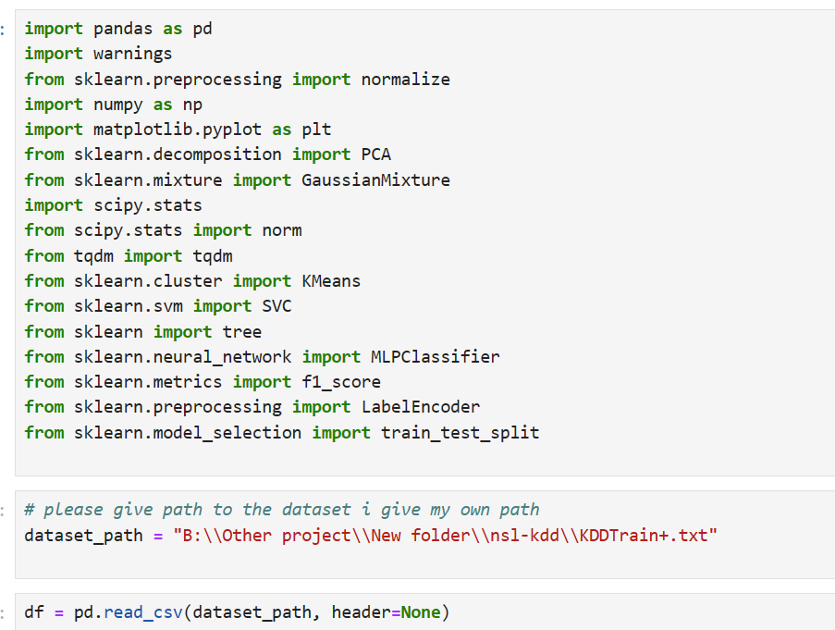

Figure 1

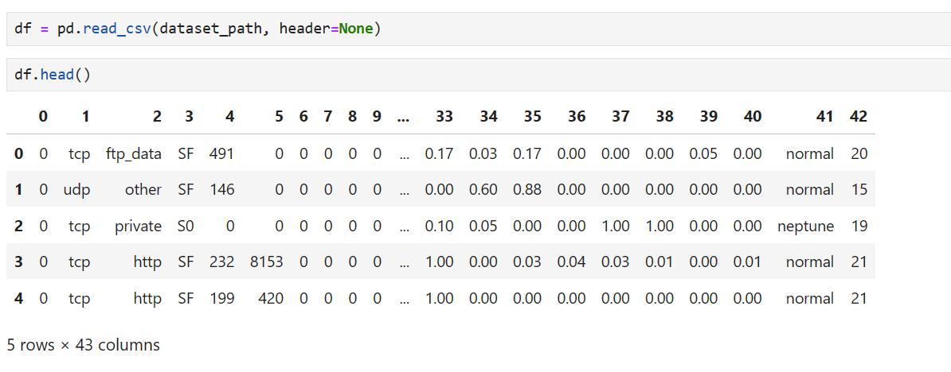

Figure 2

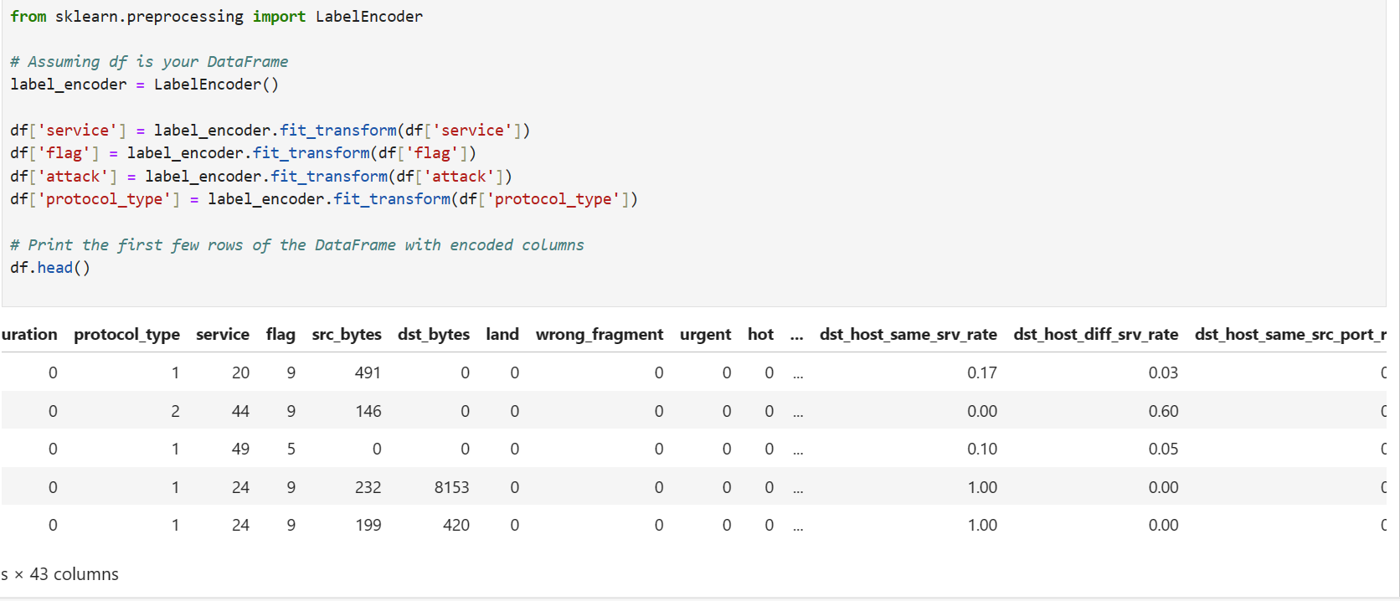

Figure 3

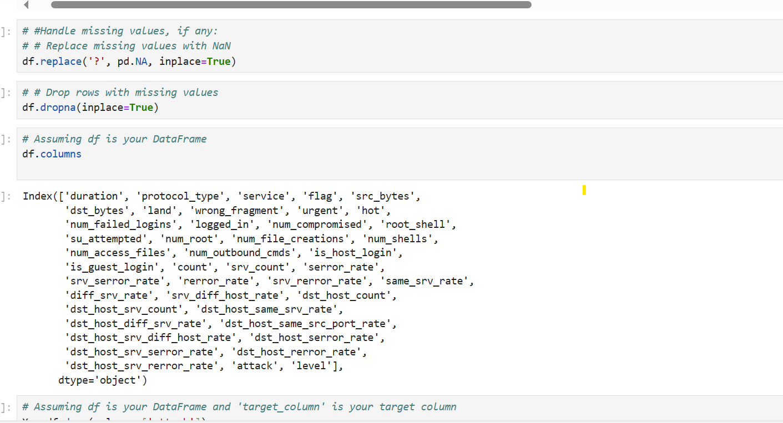

Figure 4

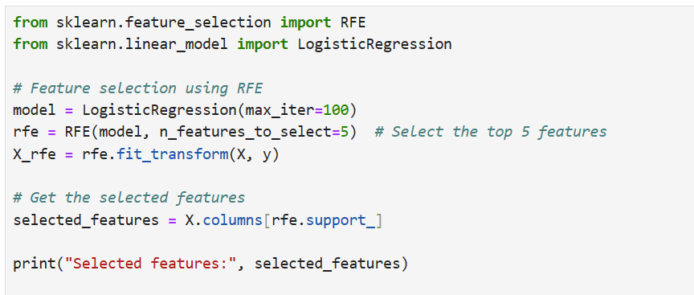

Figure 5

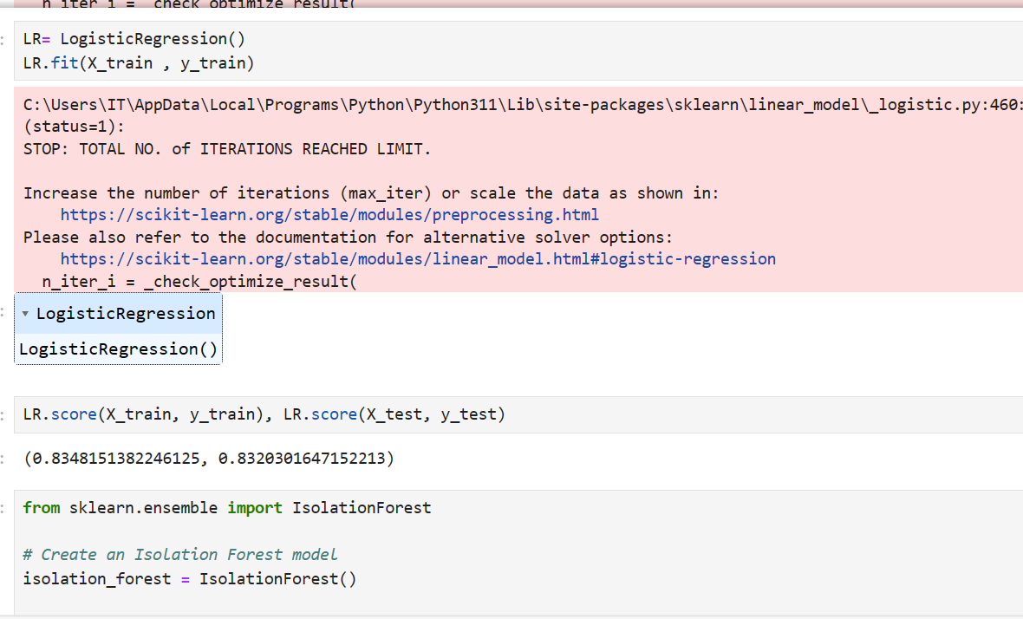

Figure 6

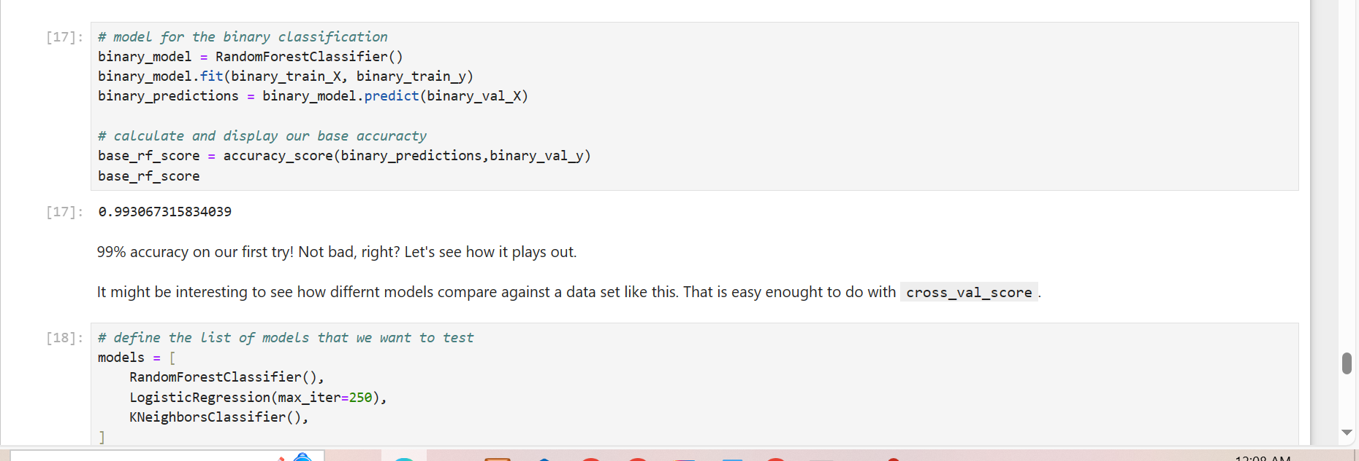

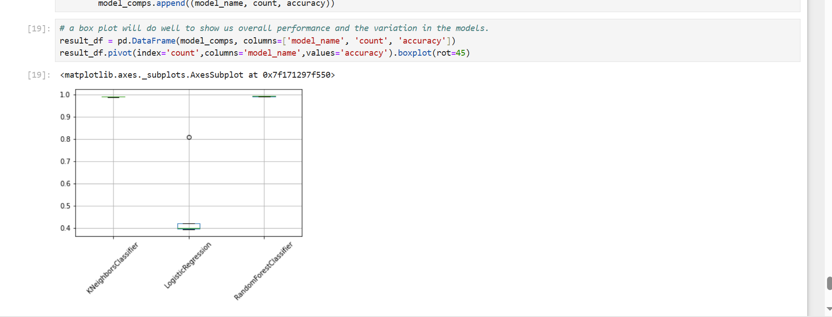

Figure 7

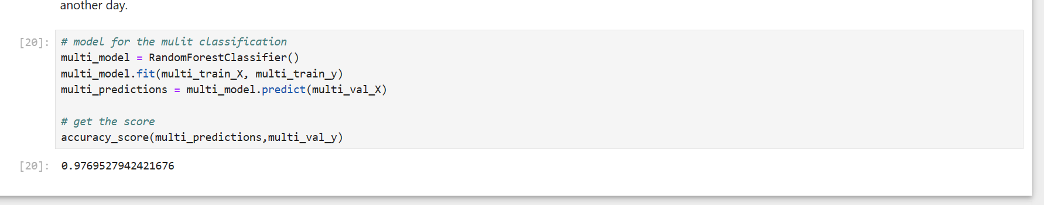

Figure 8

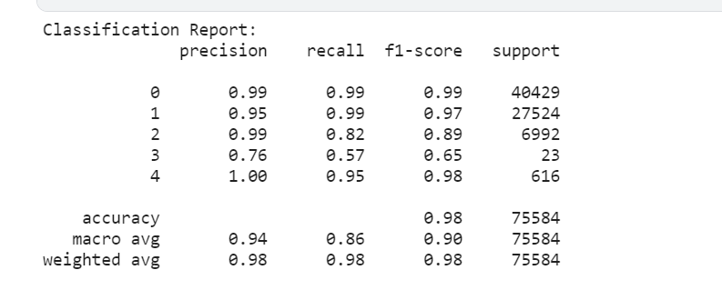

Figure 9

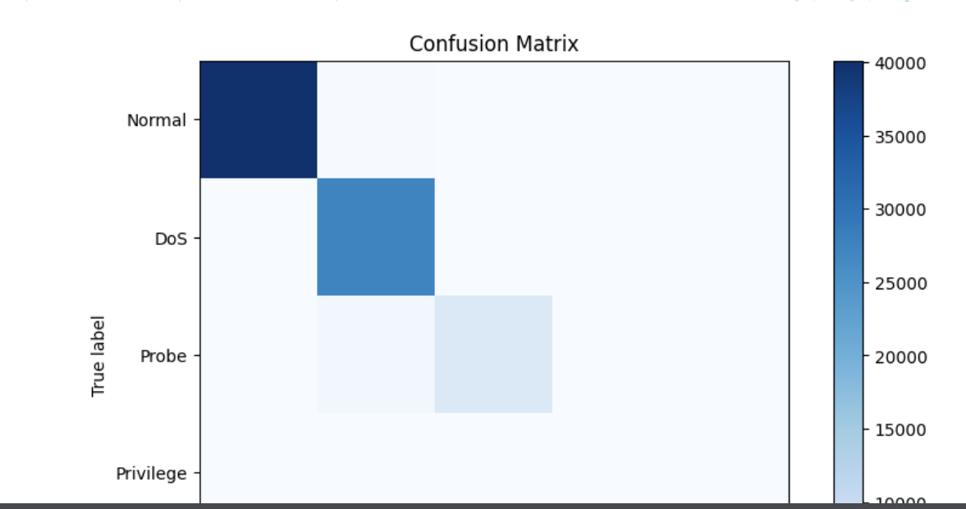

Figure 10



Figure 11

# 5. Conclusions:

This project endeavors to develop a cutting-edge anomaly detection system for network traffic, harnessing machine learning techniques. By utilizing the NSL-KDD dataset and employing algorithms such as Isolation Forest, One-Class SVM, and K-means Clustering, the project seeks to bolster the security stance of network infrastructures. Pivotal elements of the project encompass feature extraction and selection via PCA and Information Gain, alongside data preprocessing utilizing Python libraries such as scikit-learn and pandas. The project places emphasis on evaluating the anomaly detection system's effectiveness using metrics including Precision, Recall, F1-score, and AUC-ROC.

# References

[1] Shamshari, A. and Najaf, H., 2024. Machine Learning Approaches for Anomaly Detection in Network Security. *Eastern European Journal for Multidisciplinary Research*, *1*(1), pp.22-29.

[2] Vikram, A., 2020, June. Anomaly detection in network traffic using unsupervised machine learning approach. In *2020 5th International Conference on Communication and Electronics Systems (ICCES)* (pp. 476-479). IEEE.

[3] Nassif, A.B., Talib, M.A., Nasir, Q. and Dakalbab, F.M., 2021. Machine learning for anomaly detection: A systematic review. *Ieee Access*, *9*, pp.78658-78700.

[4] Elmrabit, N., Zhou, F., Li, F. and Zhou, H., 2020, June. Evaluation of machine learning algorithms for anomaly detection. In *2020 international conference on cyber security and protection of digital services (cyber security)* (pp. 1-8). IEEE.

[5] Nassif, A.B., Talib, M.A., Nasir, Q. and Dakalbab, F.M., 2021. Machine learning for anomaly detection: A systematic review. *Ieee Access*, *9*, pp.78658-78700.

[6] Dong, S., Xia, Y. and Peng, T., 2021. Network abnormal traffic detection model based on semi-supervised deep reinforcement learning. *IEEE Transactions on Network and Service Management*, *18*(4), pp.4197-4212.